Deep Learning Based Radio Signal Classification

*3 0860814,0860812 M. Farhan Tandia, Ivan Surya H*

***Abstract*—This study investigates the ……**

A signal is an observable change in quantity that carries information. A signal can carry information about virtually anything from audio to video and text data. The ability to classify signals is an important task that holds opportunity for many different applications. In a typical RF setting, a device may need to quickly ascertain the type of signal it is receiving. Consider the image above: these are just a few of the many possible signals that a machine may need to differentiate.

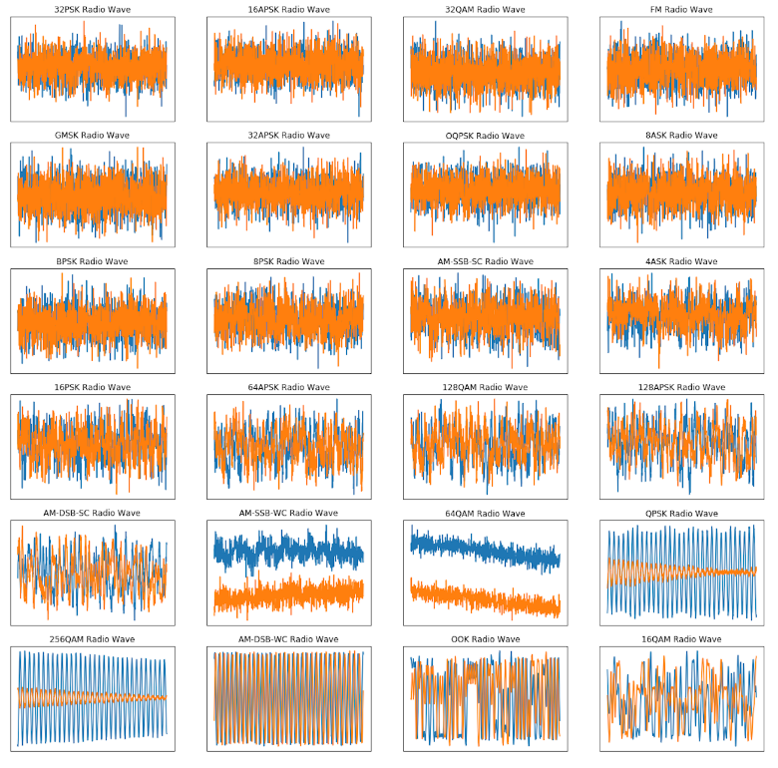

**I. Background**

In order to ….

**II. Problem Statement**

**III. Challenges**

**III. Goal**

**References**